

Name: Mubashir Ali

Roll No: 23K-6077

Section: BSE-1C

Course: Programming Fundamental

Instructor: Sir Usman Wajid

Assignment No 1

Date of Submission: 17-10-2024

**Assignment 01**

**Pseudocode and Flow Charts**

Problem: Write pseudocode and design of flow charts of simple sequence programs.

1. Write the steps of Applying for University Admission.

**PSEUDOCODE**

**START**

* Make A list and Write Universities name in which we are interested
* Get Know about university admission Requirement and admission dates etc.
* Collect Important Documents
* Academic Transcripts
* Test Score in College (if need)
* Letters of Recommendation
* Personal Statement.
* About Financial Status (need for scholarships and aid)
* Register for university test and take and type of it (for fast=NU, SAT, NTS)
* Write and correct personal statements
* Request letters of Recommendation from Teachers or Mentors
* Fill Out the Application forms of university that you listed or favorite.
* Pay the application fees (if any)
* Confirm the receipt of application materials from each university
* Apply for financial aid and scholarships
* Wait for admission Result
* Respond to result and make your final decision for that university
* Complete any additional enrollment steps required by the chosen University

**END**

**FLOW CHART**



1. Finding the average of three numbers.

**PSEUDOCODE**

**START**

* Declare Sum
* Initialize Sum to 0
* Declare num1, num2, num3;
* INPUT num1, num2, num3 from user
* Sum= num1+num2+num3
* Declare average
* Average=Sum/3
* Display average

**END**

**FLOW CHART**

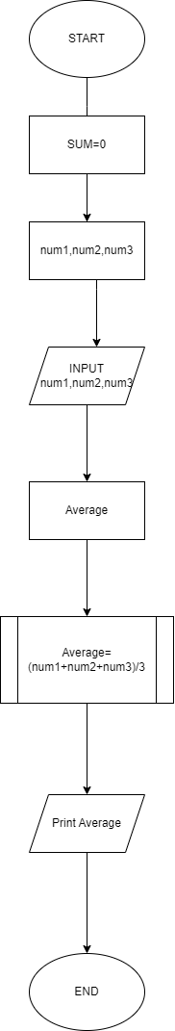

1. Add the four numbers and then take the average of four numbers.

**START**

* Declare num1, num2, num3, num4
* Declare sum, average;
* Input num1, num2, num3, num 4
* Initialize sum = num1+num2+num3+num4
* Initialize average=sum/4
* Display average

**END**

**FLOW CHART**

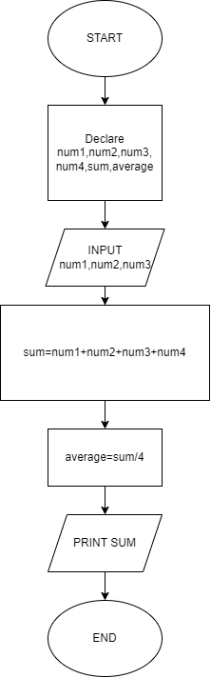

1. Find the Area of Rectangle. (AREA=LENGTH*WIDTH)

**PSEUDOCODE**

**START**

* Declare area, length, width
* Input Length, Width
* Initialize area=length*width
* Display area

**END**

**FLOW CHART**

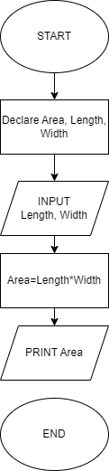

1. Write the Steps to calculate the percentage of student marks based on Math, Science, English, and Urdu. (Percentage = (Obtained / Total) * 100).

**PSEUDOCODE**

**START**

* Declare percentage, Math, Science, English, Urdu, Obtained, Total
* Input Math, Science, English, Urdu
* Calculate Obtained = Math + Science + English + Urdu
* Initialize Total = 400
* Calculate Percentage = (Obtained / Total) * 100
* Display Percentage
* END

**FLOW CHART**

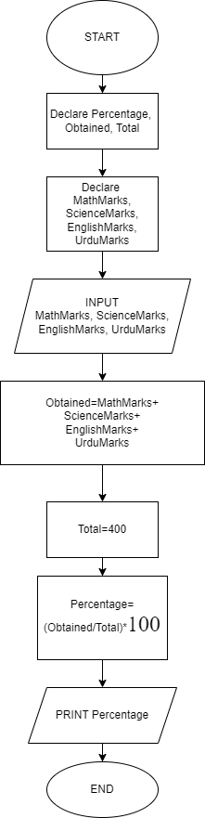

1. Calculate the Interest of a Bank Deposit (Formula "Interest=(Amount*Years*Rate/100)

**PSEUDOCODE**

**START**

* Declare Interest, Amount, Years, Rate
* Input Amount, Years, Rate
* Interest = (Amount * Year * Rate)/100)
* Display Interest

**END**

**FLOW CHART**

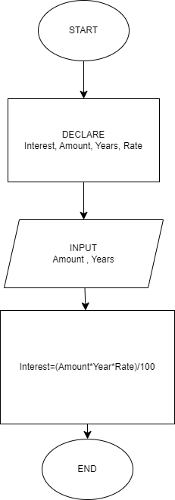

1. Convert Temperature from Fahrenheit (°F) to Celsius (°C)

Formula: C=5/9*(F-32)

**PSEUDOCODE**

**START**

* Declare Celsius, Fahrenheit
* INPUT Fahrenheit
* Celsius= (5.0/9.0) * (Fahrenheit-32)
* Display Celsius

**END**

**FLOW CHART**

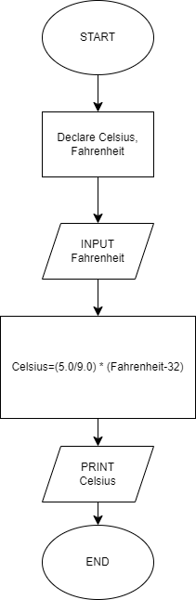

1. COMPUTE THE PERIMETER OF A RACTANGLE (Perimeter = 2*(length * Width)

**PSEUDOCODE**

**START**

* Declare Perimeter, length, Width
* Input Length, Width
* Initialize Perimeter = 2*(length*width)
* Display Perimeter

**END**

**Flow Chart**

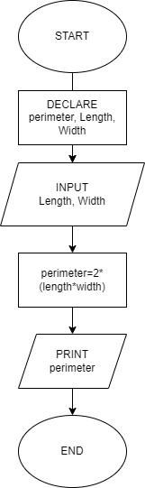

1. A Brand Offer 10% discount on each Shirt Purchased. The Original Price of Shirt is 550, Find The discounted price of one shirt. Write a Pseudocode for this problem Statement.

**PSEUDOCODE**

**START**

* Declare OrginalShirtPrice, Discount, DiscountedPriceOfShirt
* Initialize OriginalShirtPrice=550
* Input Discount
* Discount=OriginalShirtPrice*(Discount/10)
* DiscountedPriceOfShirt=OriginalShirtPrice-Discount
* Display DiscountedPriceOfShirt

**END**

1. Write a Program logic that calculates the total of a retail sale. The program should ask the user for the following: the retail price of the item being purchased and the sales tax rate. Once the information has been entered the program should calculate and display the

following: the sales tax for the purchase and the total sale

**PSEUDOCODE**

**START**

* Declare RetailPrice, SaleTax,totalsale
* INPUT RetailPrice, SaleTax,
* SaleTax=RetailPrice*(SaleTax/100)
* totalsale=RetailPrice+SaleTax
* Display SaleTax, totalsale

**END**

**Flow Chart**

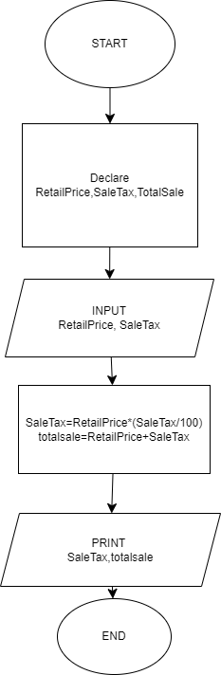

1. Write a program logic that calculate the bill of the shopping, a person purchases two keyboards each worth of 100$, three mouse each worth of 50$. Calculate the Total in PKR, (Note: Dollar to PKR 1$=215PKR)

**PSEUDOCODE**

**START**

* Declare

KeyboardQuantity,MouseQuantity,KeyboardPrice,MousePrice,PriceinPKR

* Declare MouseinPKR,KeyboardinPkr
* Initialize KeyboardPrice=100
* Initialize MousePrice=50
* INPUT KeyboardQuantity, MouseQuantity
* KeyboardinPKR=KeyboardQuantity*KeyboardPrice
* MouseinPKR=MousePrice*MouseQuantity
* Display KeyboardinPKR,MouseinPKR

**END**

**Flow Chart**

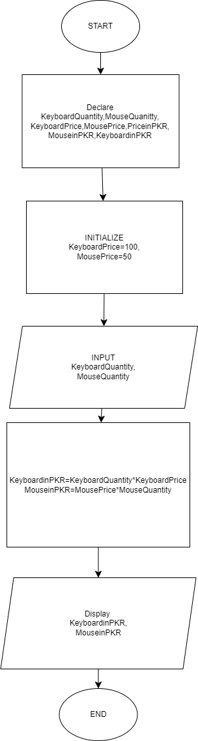

1. Write a program that calculates the current balance in a savings account. The program should obtain from the user the following information: the starting balance, the total amount of deposits made, and the total amount of withdrawals made. After the program has calculated the current balance, it should be displayed on the screen. Assume one input for deposits and one input for withdrawals. Make the pseudo-code for this problem.

**PSEUDOCODE**

**START**

* Declare startingbalance, totaldepositamount, totalwithdrawalsamount, currentbalance,totaldeposit
* INPUT startingbalance,totaldepositamount, totalwithdrawalsamount
* totaldiposit=totaldipositamount+startingbalance
* currentbalance=(totaldiposit-totalwithdrawalamount)
* Display currentbalance

**END**

END OF ASSIGNMENT NO 1

PROGRAMING FUNDAMENTAL

SECTION BSE-1C

ROLL NO: 23K-6077

Submitted on Date 14-09-2024